Year 8 Religious Education

Commencement Classes Booklet

***Who is Jesus?***

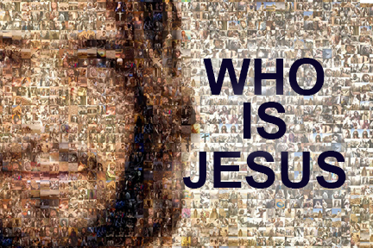

**Name: Christian Rocci**

**Tutor Group: L13**

**Teacher’s Name: Mr Lim**

***Introduction***

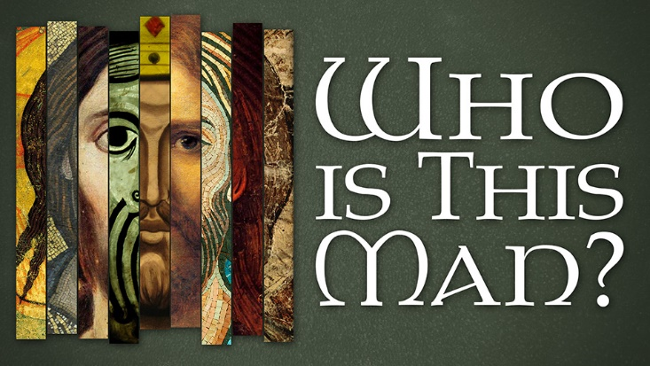Welcome to year 8 Religious Education. This Term you will be learning about Jesus, about the land and country of his birth, as well as about the people he encountered in his everyday life.

There will be two Assessment Tasks during Term 1:

1. A Brochure on First Century Palestine; and
2. A written piece about an ‘Encounter with Jesus’.

***What do you know about Jesus?***

Many of you may already know who Jesus is, but some of you may be unsure. In the box below, brainstorm some ideas about who ***you think*** Jesus is and note them down. If you are unsure or uncertain, jot down things that you have heard about him. You may wish to share your ideas with the class.

* Jesus is the Messiah (Saviour)
* Jesus is God’s only son, who was sent down to Earth to teach us to be better people, before dying for our sins, even though we were the people who ordered his death.
* Jesus is one third of the Holy Trinity: The Father, The Son (Jesus), and the Holy Spirit.

What are some things that you discovered about Jesus from your class discussion?

|  |
| --- |
| * Jesus’ name is very important, as every knee should bend in heaven and on earth and under the earth |

Was there anything that surprised you and that you didn’t know about Jesus?

|  |
| --- |
|  |

During this Unit of study, what is something that you would like to discover or learn about Jesus?

|  |
| --- |
| * **I want to learn as much as possible about Jesus’s life, and what I don’t know about him.** |

**Student Life Timeline**

Before delving into a study of Jesus’ birth and life, you are to look at your own life and family tree, and identity key people who have had an impact on you. Using the timeline below, note key dates, events and key figures next to them. The first one has been partially completed to guide you.

**Key People**

**Dates/ Events**

**-Born 5/6/2009 Mum: Josie, Dad: Mario**

**Brother: James**

**-Kindergarten 2012**

**-Prep 2015 (At Holy Spirit Primary School)**

**-Left Year 6 2021**

**-Started Year 7 2022**

**-Started Year 8 2023 (To Come…)**

**Life of Jesus**

Now that we have had a look at your life, we will turn to the life of Jesus, and in so doing, we will gain greater knowledge about him, as well as learn about key dates, places of importance, key events and key people in his life. The four canonical gospels (Matthew, Mark, Luke and John) as well as Acts of the Apostles (written by Luke), detail the story of Jesus. Two of those Gospels talk about his birth, namely Matthew and Luke, and they are known as the Infancy Narratives.

1. ***Jesus’ Birth***

Matthew and Luke each describe Jesus’ birth and both write that the angel Gabriel appeared to Mary, a young devout Jewish girl who was said to be poor, and the angel said to her:

In Matthew, the angel tells Mary to name her son Emmanuel, meaning “God is with us.”

In Luke, the angel tells Mary to name her son Jesus, which is a Hebrew name for Joshua, meaning “God is salvation.”

“Do not be afraid, Mary, for you have found favour with God. 31 And now, you will conceive in your womb and bear a son, and you will name him Jesus. Mary said to the angel, “How can this be, since I am a virgin?”35 The angel said to her, “The Holy Spirit will come upon you, and the power of the Most High will overshadow you; therefore the child to be born will be holy; he will be called Son of God (*Luke 1:30-35*).

Scholars believe that Jesus was born during the time of Herod between 4-6 CE.

*Activity:*

1. Why do you think Mary might have been afraid?

|  |
| --- |
| She may have been afraid because an angel, something not normally seen, has appeared in front of her. She may also know that this means something important will happen. |

1. Why did God select Mary to bear his child?

|  |
| --- |
| God selected Mary to bear his child because Mary found favour with God. |

1. What does the term ‘virgin’ mean?

|  |
| --- |
| The term virgin refers to someone who hasn’t participated in sexual intercourse. |

1. Highlight the passage that explains how Jesus was conceived.

At the time of these events, Mary was engaged to a young man named Joseph. The same angel also appeared to Joseph, and he explained that the child Mary was carrying was conceived by the Holy Spirit and was God’s son.

The Gospels differ regarding the details of Jesus’ birth. Matthew writes that Mary gave birth to a son named Jesus, as prophesised by the angel, and he writes that three wise men from the East came to Jerusalem and asked Herod, *“Where is the child who has been born king of the Jews? For we observed his star at its rising, and have come to pay him homage”(Matthew 2:2*). At hearing that his kingship was under threat, Herod issued a decree ordering that all male children under the age of two be killed. An angel appeared to Joseph yet again and told him to flee to Egypt and not to return until such time as Herod’s reign comes to an end. So, Joseph, Mary and Jesus fled to Egypt as instructed by the angel.

Luke’s Gospel states that Joseph, Mary’s husband being a descendant of King David, was required to return to Bethlehem as Emperor Augustus had decreed that a census to be undertaken and all citizens were to be registered. Whilst there, Mary gave birth to Jesus in a barn, and three shepherds came to visit Jesus who was placed in a manger (which is an animal feeding trough) as there were no rooms available in any of the inns. After his birth, Jesus was taken to the temple in Jerusalem and circumcised, as was required by Jewish law.

*Activity:*

1. Look at the images below and identify which Infancy Narrative the image depicts the story told in either Matthew or Luke. You will need to use your Bible to assist you.

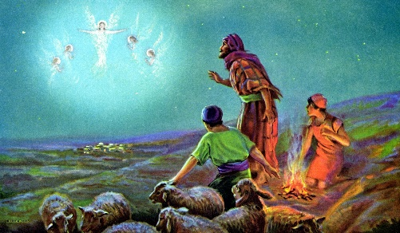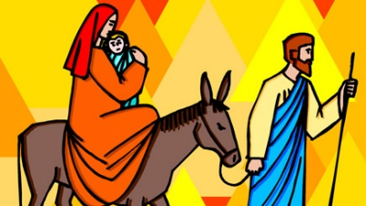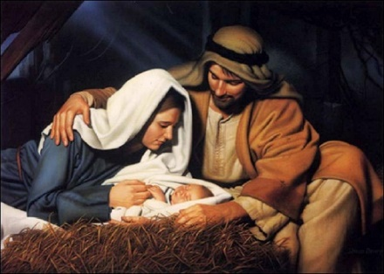

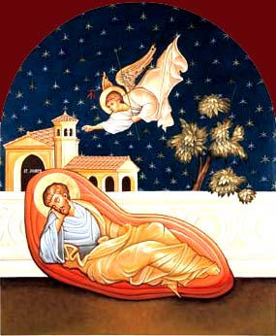

Luke Matthew Luke

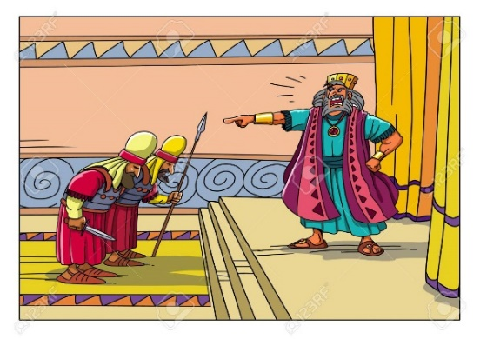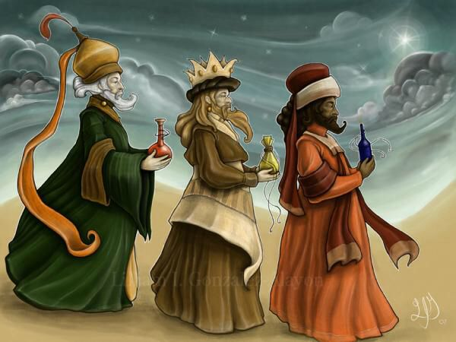

Luke Matthew Matthew

1. ***Jesus at the Temple***

We meet Jesus again in the Gospel of Luke when he is twelve years old, when he attends the Passover with his parents. Passover is a significant festival for the Jewish people as it represents the time when Moses liberated the Jewish people from slavery in Egypt. Many devout Jews undertake a pilgrimage to Jerusalem by foot, which sometimes takes many days and weeks, in order to offer a sacrifice at the Temple. After the festival, Mary and Joseph left to return home, and assuming that Jesus was in the crowd, walked for an entire day before realising that he was not with the group of travellers. When they returned, they found him at the Temple having a conversation with the Pharisees, who were the keepers of the Jewish laws, and everyone who heard Jesus was amazed at his wisdom. There is no further mention about the child Jesus after this event, only that he lived in a town called Nazareth in Galilee, and that he took on the profession of his earthly father, Joseph, and became a skilled carpenter.

*Activity*

1. Have you ever been lost or separated from your parents or your family? How did you feel? Does Jesus seem concerned about having been left behind for an entire day? Share your answers with the class.

|  |
| --- |
| * I can’t say that I’ve even been lost from my parents. * Jesus doesn’t seem concerned about his parents, as he was the one who stayed behind. This could be because he knew his parents would come back. |

1. ***Jesus’ Baptism***

Jesus was baptised when he was thirty years old by his cousin, John the Baptist, in the Jordan River. During his baptism, the Synoptic Gospel writers (Matthew, Mark and Luke) state that as Jesus was coming up from the water, the heavens opened up and he saw the Spirit of God descending on him like a dove. Also, a voice was heard proclaiming Jesus as God’s “beloved son” with whom God is pleased.

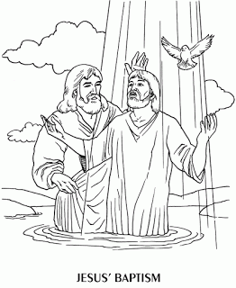

1. ***Jesus’ Temptation***

Right after Jesus’ baptism, he is led by the Spirit to the wilderness where he is tempted for forty days and forty nights, without any food or water. Satan tries to coax and persuade Jesus to follow him instead of the one true God, by promising to give him every nation in the world. However, Jesus passes the test and does not succumb, even though he was 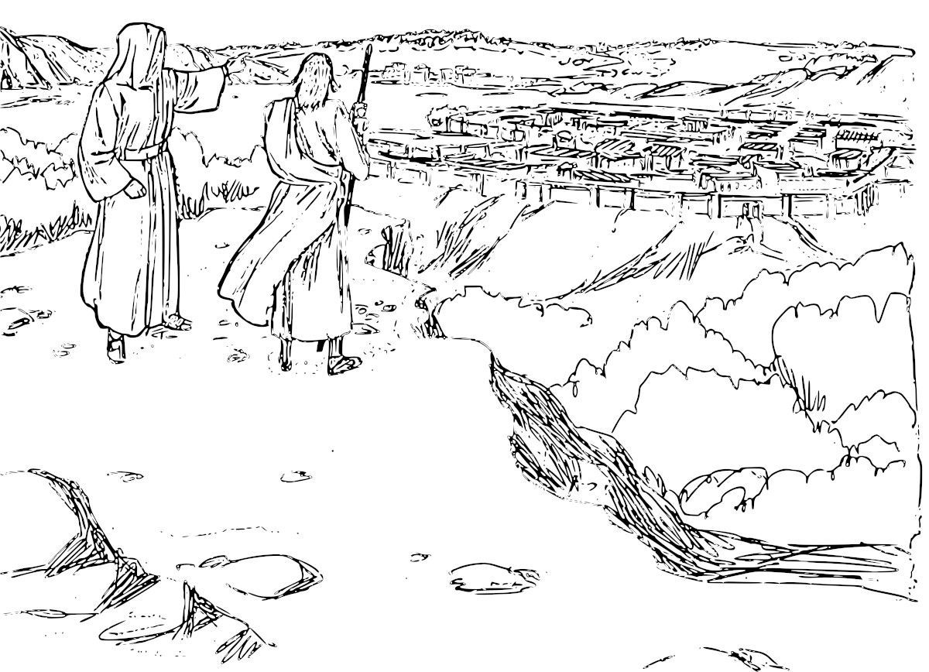experiencing severe hunger and thirst. Jesus told Satan that there was only one true God.

A **synagogue** is a building in which Jews meet for religious worship or instruction.

1. ***Jesus Begins his Ministry***

Immediately following his temptation in the wilderness, and filled with the Holy Spirit, Jesus begins his ministry. He teaches in **synagogues** and is praised by everyone who hears him. One Israelite is astounded by Jesus’ wisdom and asks, “Is this not Joseph’s son?” Jesus informed the Israelites that God’s salvation was for all of humanity and not just for the Israelite people, who were God’s ‘Chosen People’. This angered the people, and they were so outraged that they wanted to hurl Jesus off a cliff. They believed that salvation was only available to them, given that they had a special bond and relationship with God. However, Jesus was able to walk past them unharmed, and he continued on his journey of teaching and healing people.

**Disciple –** a follower of Jesus during his life, especially the twelve disciples chosen by Jesus. After Jesus’ death, the disciples were known as apostles.

*Activity*

7. Read *Luke 5:11* and answer the questions below:

(a) On the map below, mark the location Jesus was when he called his **disciples**.

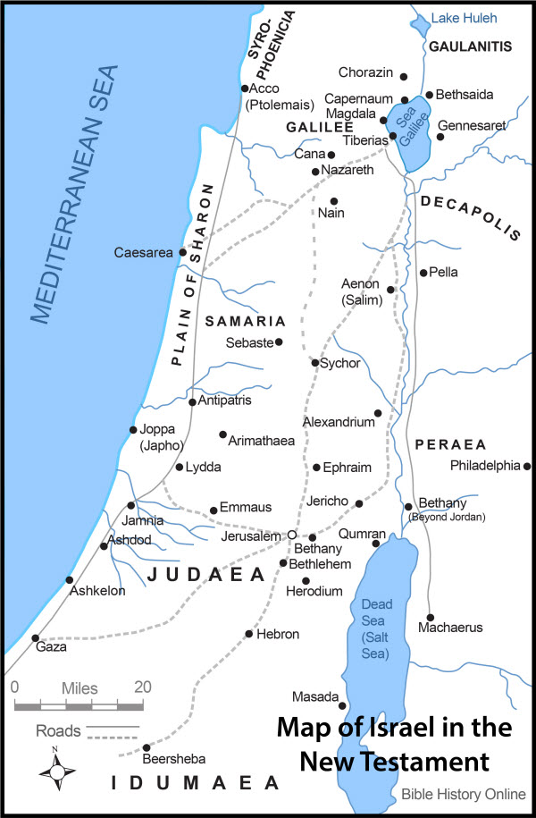

(b) Whose boat did Jesus enter?

|  |
| --- |
| Jesus boarded Simon’s boat. |

(c) What did Jesus ask of Simon and what was Simon’s response?

|  |
| --- |
| Jesus told Simon to move the boat from shore, then drop his net. Simon was puzzled, as they haven’t caught anything all night, but still dropped down the net. |

(d) What miracle did Jesus perform?

|  |
| --- |
| Despite not catching anything all night, the net they threw down on Jesus’ command came back up full of fish. |

(e) What was Simon Peter’s response to this miracle?

|  |
| --- |
| Simon was shocked, and fell to Jesus’ knees, saying “Go away from me, Lord, for I am a sinful man! |

(f) Name the three men who followed Jesus.

|  |
| --- |
| Simon, James and John. |

(g) Read *Luke 6:12-16* and name Jesus’ twelve disciples.

|  |
| --- |
| Andrew, Bartholomew, James son of Zebedee, James son of Alpheus, John, Judas, Jude, Matthew, Simon Peter, Philip, Simon the Zealot, Thomas |

1. ***Jesus’ Miracles***

Jesus walked from Galilee to Jerusalem with his disciples, and along the way, he performed many miracles. There are four types of miracles: healing miracles, nature miracles, exorcisms and resurrection miracles.

|  |  |
| --- | --- |
| **Type of Miracle** | **Definition** |
| Healing | A supernatural and divine healing through the power of the Holy Spirit, which often, but not always, involves the laying of hands. |
| Nature | An extraordinary even that cannot be explained by natural or scientific laws and is attributed to a divine agency. |
| Exorcism | The expulsion of an evil spirit. |
| Resurrection | The act of bringing someone back to life after they have been declared dead. |

*Activity:*

8. Locate the passages below and identify the type of miracle performed by Jesus.

|  |  |
| --- | --- |
| **Passage** | **Miracle Performed** |
| John 2:1-11 | Nature |
| Matthew 9:18-26 | Healing and Resurrection |
| Mark 1:23-28 | Exorcism |
| Luke 7:11-18 | Resurrection |
| Matthew 8:23-27 | Nature |
| John 11:1-46 | Resurrection |
| Matthew 9:1-8 | Healing |
| Luke 8:43-48 | Healing |
| Matthew 17:14-21 | Exorcism |

1. ***Jesus’ Teachings***

Did you know that the Jewish people have to follow 613 laws? 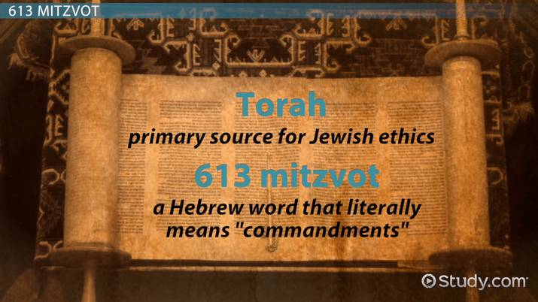

Jesus mission on earth was to re-educate the High Priest, Priests, Sadducees Scribes, Pharisees, the people with authority and all of the Israelites that God loves all of humanity, not just the Chosen People. He also taught that it was not necessary to be so strict about following all of the laws, given that there were so many. He said that the goal of Jewish life was to embody the Torah (the first five books of the Old Testament in the Bible) and to live in a way that brings people closer to God. Jesus wanted to teach a different way of living, a less oppressive way of loving God, and one that was not so burdensome on people, especially the poor. Jesus also taught that the Kingdom of God was near and that the sinners had to ***repent*** if they wished to enter God’s Kingdom. He made it clear that everyone was welcome, especially the sinners, as every single person matters to God, not just the rich and pious.

**Repent-** to feel or express sincere regret or remorse about one's wrongdoing or sin.

*Activity:*

9. Read the passages below and write down three things that Jesus believes is important in living a good life, and one that brings one closer to God.

*Matthew: 5:1-11* and *Luke 6:27-42*

|  |
| --- |
| Jesus believes that to have a good life, you must be humble, merciful, and pure in your heart. |

1. ***The Identity of Jesus***

*Activity:*

10. Read the passages below and identity who the figures proclaim Jesus to be:

|  |  |
| --- | --- |
| **Passage** | **Jesus’ Identity** |
| Matthew 3:17 | Jesus is God’s Son |
| Luke 4:33-34 | Jesus is Jesus of Nazareth, and the Holy One of God |
| Luke 9:20 | Jesus is God’s Messiah |
| Luke 9:35 | Jesus is my (God’s) Son |
| John 20:17 | Jesus is God’s Son |

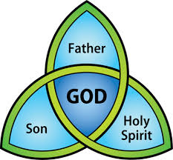The Scriptures teach and Catholics believe that Jesus was God himself and thus forms the Trinity.

Jesus was three persons, he was:

* God the Father
* God the Son
* The Holy Spirit

1. ***Opposition against Jesus intensifies***

Jesus’ followers were growing in number, as people liked the good news that Jesus was teaching, particularly about God being accepting of all people. Jesus was also challenging the Jewish leaders and challenging their teaching. Moreover, he believed that they did not gather the flock of people, but rather separated them into distinct groups. The High Priest, Priests, Sadducees, Scribes, and Pharisees, who were the leaders of the law did not have any contact with people they deemed sinners and outcasts, nor did they reach out to them to lend a hand and try to assist them. Jesus, however, did just that. He associated with the sinners and the outcasts, he dined and visited the homes of Tax Collectors, who were hated by the Jewish people because they often charged excessive tax, and they were employed directly by the Romans, whom the Jews also hated. Many of the outcasts and sinners repented, asked for forgiveness and became followers of Jesus.

**Sabbath** - A day of religious observance and abstinence from work, kept by Jewish people from Friday evening to Saturday evening.

Another reason the Jewish leaders hated Jesus was because he healed on the **Sabbath**. They accused Jesus of breaking one of the Ten Commandments and they wanted to punish him for it.

**Blasphemy-** the action or offence of speaking sacrilegiously about God or sacred things.

They also were angered when Jesus said that he forgave people for their sins, as they said only God had the authority to forgive sins. Jesus never told anyone that he was the Son of God because he knew that he would have accused him of **blasphemy**.

*Activity:*

11. Look up the Ten Commandments and locate and write down the law that Jesus is accused of breaking.

|  |
| --- |
| Jesus is accused of breaking the 5th Commandment: Honour your father and mother.  Luke 2:48 |

12. Highlight the reason the Chief Priests and Scribes were plotting for a reason to kill Jesus in the passage below.

*Mark 11:15-19 New Revised Standard Version (NRSV)*

**Jesus Cleanses the Temple**

15 Then they came to Jerusalem. And he entered the temple and began to drive out those who were selling and those who were buying in the temple, and he overturned the tables of the money changers and the seats of those who sold doves; 16 and he would not allow anyone to carry anything through the temple. 17 He was teaching and saying, “Is it not written,

‘My house shall be called a house of prayer for all the nations’?

But you have made it a den of robbers.”

18 And when the chief priests and the scribes heard it, they kept looking for a way to kill him; for they were afraid of him, because the whole crowd was spellbound by his teaching. 19 And when evening came, Jesus and his disciples went out of the city.

1. ***The Last Supper, Betrayal and Arrest***

Jesus and his disciple arrive in Jerusalem for Passover. You may recall that Jesus attended the Passover with his parents when he was twelve years old.

*Activity:*

13. Read *Mark 14:22-25* and complete the table below.

|  |  |
| --- | --- |
| **Item** | **Meaning** |
| Bread | Bread is the Body of Christ |
| Cup | The Chalice contains the Blood of Christ |

14. View the YouTube clip <https://www.youtube.com/watch?v=wY8hhoYeVTw> and write down three things about the betrayal of Jesus.

|  |
| --- |
| Youtube didn’t work :/ |

1. ***The Death of Jesus***

After Jesus’ arrest, the Jewish leaders brought him to Pontius Pilate under the charge of perverting the people and stirring them in order to cause a rebellion against Roman authorities. They also accused him of forbidding people from paying taxes to the Romans. Pilate could not find a reason to charge Jesus, so he had him flogged instead. However, the leaders were insistent that he be crucified, a punishment that was only handed out to the most dangerous and despised criminals. Pilate felt that he had no choice but to consent to the Jewish religious leaders, and as such, ordered that Jesus be crucified.

**Crucifixion** - a form of execution in which a person was nailed or bound to a cross.

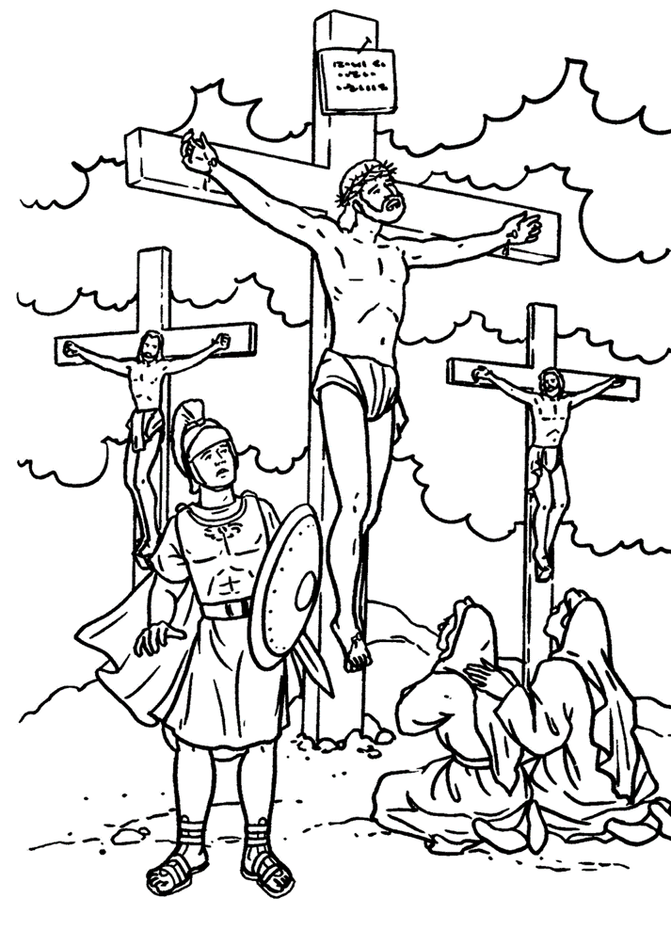

Jesus was crucified at a place outside Jerusalem called Golgotha (which in Aramaic means “place of the skull”), alongside two other criminals. Joseph of Arimathea went to Pilate and asked for the release of Jesus’ body, so he could prepare the body and bury it in a tomb, as was the Jewish custom. Jesus was thirty-three years of age when he was crucified.

1. ***The Resurrection of Jesus***

Activity:

15. Complete the Cloze Activity – *Luke 24:1-12 NRSV*

But on the first day of the week, at early dawn, they came to the tomb, taking the spices that they had prepared. 2 They found the stone rolled away from the tomb, 3 but when they went in, they did not find the body.[a] 4 While they were perplexed about this, suddenly two men in dazzling clothes stood beside them. 5 The women[b] were terrified and bowed their faces to the ground, but the men[c] said to them, ‘Why do you look for the living among the dead? He is not here, but has risen.[d] 6 Remember how he told you, while he was still in Galilee, 7 that the Son of Man must be handed over to sinners, and be crucified, and on the third day rise again.’ 8 Then they remembered his words, 9 and returning from the tomb, they told all this to the eleven and to all the rest. 10 Now it was Mary Magdalene, Joanna, Mary the mother of James, and the other women with them who told this to the apostles. 11 But these words seemed to them an idle tale, and they did not believe them. 12 But Peter got up and ran to the tomb; stooping and looking in, he saw the linen cloths by themselves; then he went home, amazed at what had happened..

1. 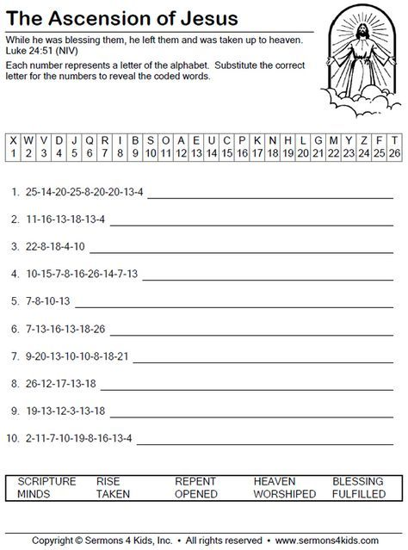***Ascension of Jesus***

Jesus remained with his disciples for forty days, and then ascended into heaven. He instructed his followers to spread the good news about God’s Kingdom to all the nations of the world. The story of Jesus’ disciples and the beginning of the Christen Church continues in the Acts of the Apostles (ACTS).

Opened

Fulfilled

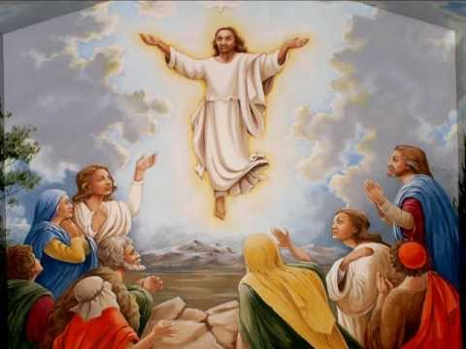

Worshiped

Heaven

Taken

Blessing

Repent

Rise

Scripture

Minds